Level Up to VET game

A new Mobile Game to help you look at waht you can do and where it can take you

The Level up 2 VET game is a new and exciting game for smartphones and tablets designed to help young people learn about the exciting career options which are available to them in the VET sector and what is involved in each career path, from picking a career to training for that career to mastering that career!
Level Up 2 VET is a digital board game, where players navigate a 3D animated game board by rolling the dice and moving through the world. Along the way, players have to collect as much experience as possible by picking cards, playing minigames, and managing their money and time!

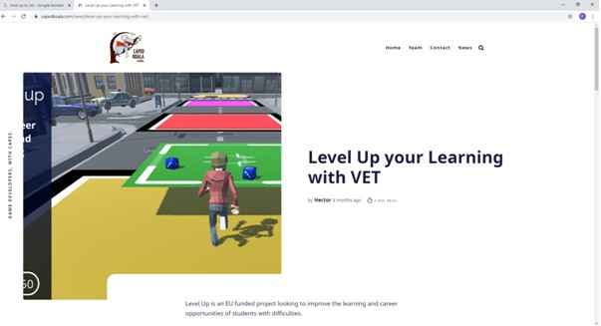

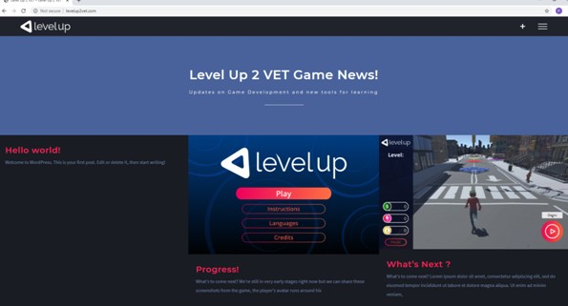

More information:
http://levelup2vet.com/
https://lu.capedkoala.com/app
http://levelupvet.eu/

